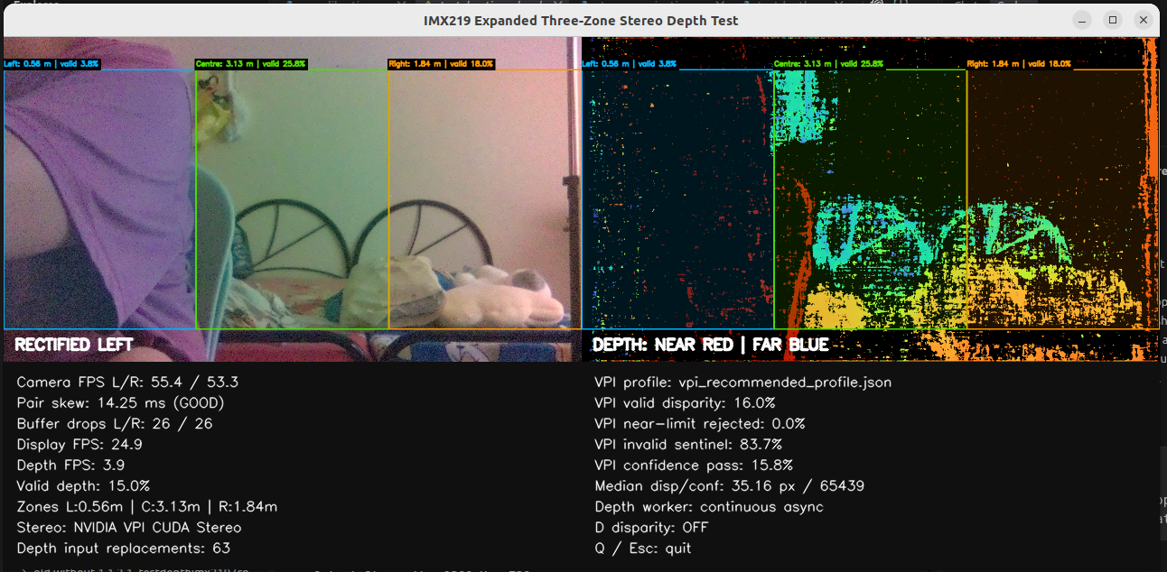
Tittle and button something
Stream video
Log
Zone value
Zone value
Zone value

